**DAILY ONLINE ACTIVITIES SUMMARY**

|  |  |  |  |  |  |  |  |
| --- | --- | --- | --- | --- | --- | --- | --- |
| **Date:** | | **31/05/2020** | | | | | |
| **Name of the Faculty** | | **Ankitha Shetty** | | | | | |
| **No. of Students Allotted for monitoring** | | | | | **16** | | |
| **Progress** | | | | | **Good** | | |
| **Whether collected report from all the allotted students** | | | | | **No.**  **Few students have done certification course** | | |
| **Online Test Summary** | | | | | | | |
| **Subject** | **Operation Research** | | | | | | |
| **Semester** |  | | | **Duration** | |  | |
| **No. of students Taken** | | |  | **Passing %** | |  | |
| **Certification Course Summary** | | | | | | | |
| **Course** | | Programming concept with python | | | | | |
| **Certificate Provider** | | Alison | | | **Duration** | | **3 hours** |
| **Coding Challenges** | | | | | | | |
| **Problem Statement:** | | | | | | | |
| **Status:** | | | | | | | |
| **Uploaded the report in Github** | | | | | **Yes** | | |
| **If yes Repository name** | | | | | <https://github.com/ankishetty91/ankitha-daily-report> | | |
| **Uploaded the report in slack** | | | | | **Yes** | | |

**Certification Course Summary**

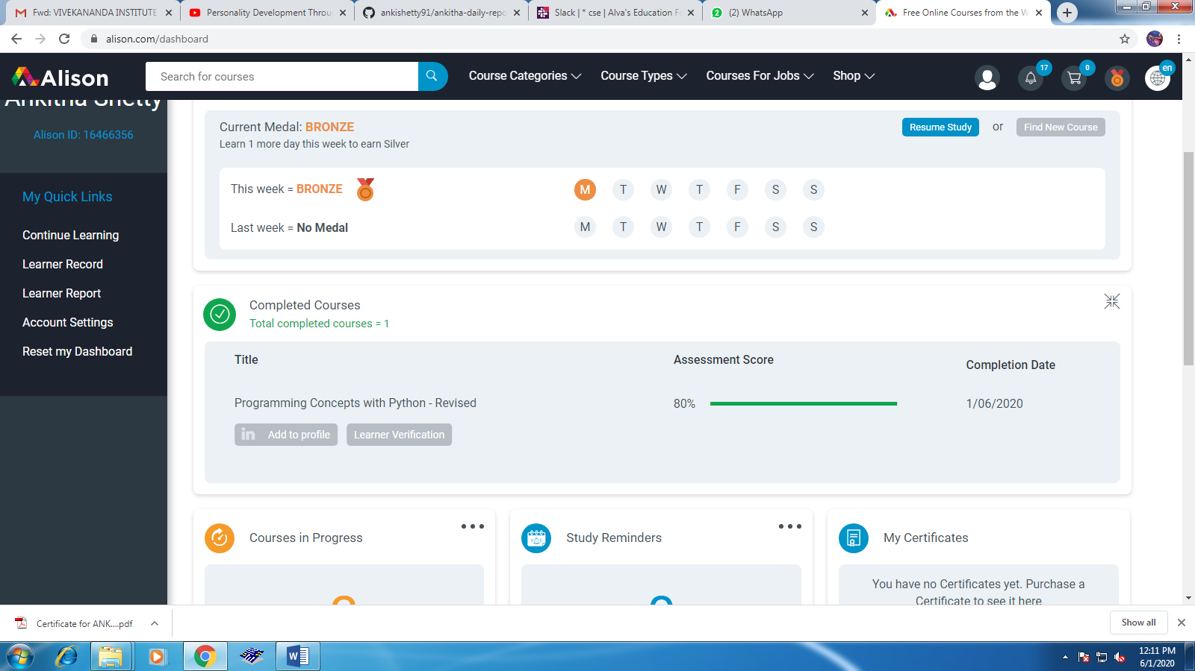

**Students Report:**

